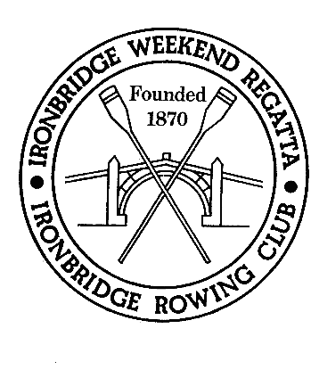
SAFEGUARDING JUNIORS AND VULNERABLE ADULTS
IRONBRIDGE ROWING CLUB EVENT
EMERGENCY CONTACT DETAILS

The Event Organising Committee believes that the welfare and wellbeing of all our competitors is paramount. All children, regardless of age, gender, ethnicity, religion or ability, have equal rights to safety and protection.

All suspicions, concerns and allegations of harm will be taken seriously and should be reported without delay to an Ironbridge Rowing Club volunteer or Event Official, whereupon they will be responded to swiftly and appropriately in accordance with the Event Child Welfare Plan.

In order to effect best management of matters arising in relation to child athletes, all clubs entering junior athletes will be required to provide the name and mobile telephone number of at least one club representative assuming responsibility for these children.

These details will be requested at the point of registration on each day of the event, and will not be used for any other purpose. This will be destroyed following the completion of the event.

NAME OF ROWING CLUB: _____________________________________________________________

DATE OF COMPETITION: ______________________________________________________________

NAME OF CONTACT 1: _______________________________________________________________

MOBILE PHONE NUMBER OF CONTACT 1:________________________________________________

NAME OF CONTACT 2: _______________________________________________________________

MOBILE PHONE NUMBER OF CONTACT 2: _______________________________________________

The Event Organising Committee thank you for your assistance in the safeguarding of child athletes.

